An Internship Report
Of
Design and Development of an Online Property Tax Payment Portal for E-Governance & Digital Services
Submitted
To
School of Computer Science and Engineering
IILM University, Greater Noida, U.P.
In partial fulfilment of the requirement of degree of
B.Tech (CSE)

By
Roll Number of Student: 2410031494
Name of Student: PALAK RAMTRI
Batch: 2026-27

CANDIDATE'S DECLARATION
I, PALAK RAMTRI, do hereby declare that the internship report titled “Design and Development of an Online Property Tax Payment Portal for E-Governance & Digital Services” has been completed by me to fulfil the requirement for the award of the degree of Bachelor of Technology in Computer Science and Engineering. All the references have been quoted and I have not taken as such any material from any other source. I affirm that this report is my own and has not been submitted to any other institute for any degree/diploma requirement, and further I shall be solely responsible for any kind of copyright violation in this regard.
Signature:-
Student Name: PALAK RAMTRI
Roll No.: 2410031494

ACKNOWLEDGEMENT
I am using this opportunity to express my gratitude to everyone who supported me throughout the Internship Program. I am thankful for their aspiring guidance, invaluably constructive criticism, and friendly advice during this work. I am sincerely grateful to them for sharing their truthful and illuminating views on a number of issues related to this work.
I would like to thank the YuvaIntern team, including Mr. Kounal Gupta, Founder of YuvaIntern, for providing me the opportunity and the structured platform to learn and gain hands-on exposure in the domain of Junior Web Developer – E-Governance & Digital Services. I am also thankful to my institute, IILM University, Greater Noida, and the faculty of the School of Computer Science and Engineering for their continuous support and encouragement.
I express my gratitude to my parents for their blessings.
Signature:
Student Name: PALAK RAMTRI
Roll No.: 2410031494

TABLE OF CONTENTS
1. Candidate's Declaration i
2. Acknowledgement ii
3. Internship Completion Certificate -
4. Project Description 1
4.1 Introduction 1
4.2 Organization Profile 1
4.3 Problem Statement 2
4.4 Project Objectives 2
4.5 Scope of the Project 2
4.6 Technologies and Tools Used 3
4.7 System Architecture 3
4.8 Methodology 4
4.9 Expected Outcomes 5
4.10 Certificates of Completion and Communication Proof 5
5. Bibliography/References 7

3. INTERNSHIP COMPLETION CERTIFICATE
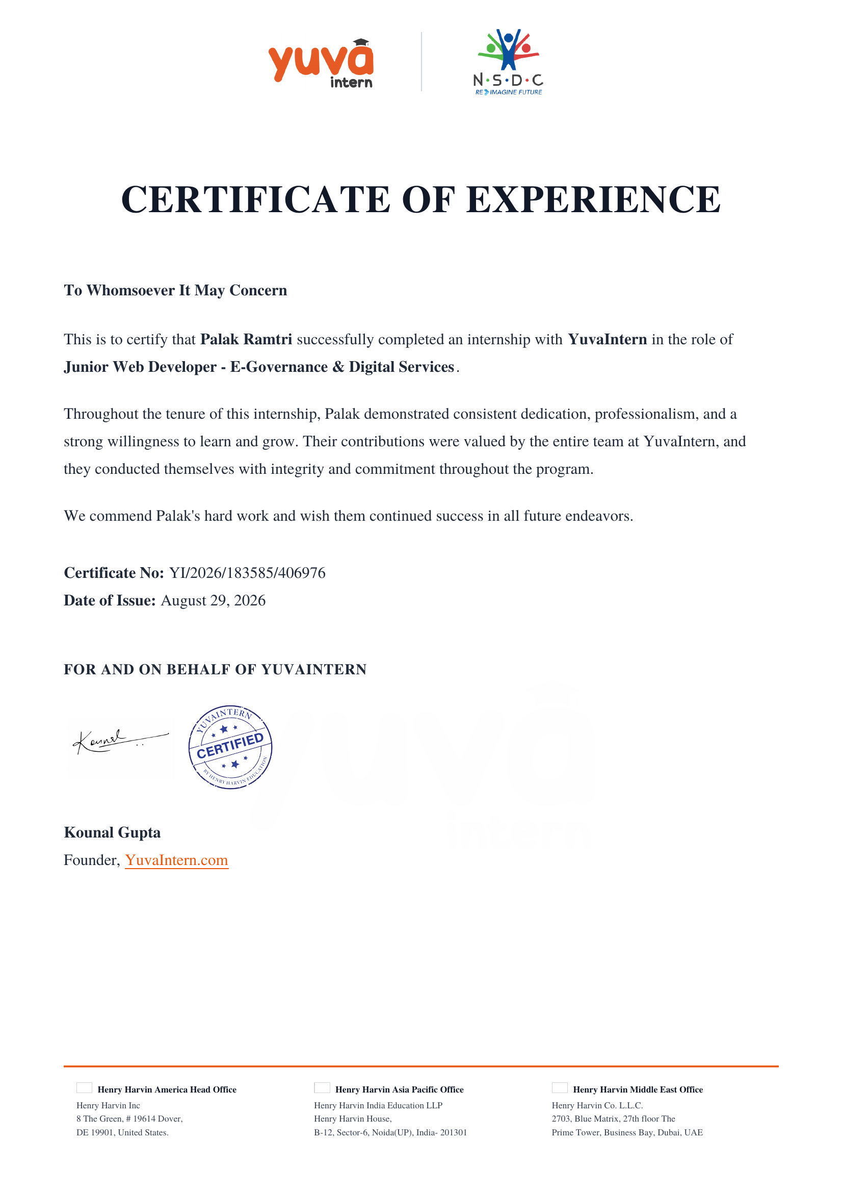

Internship Offer Letter
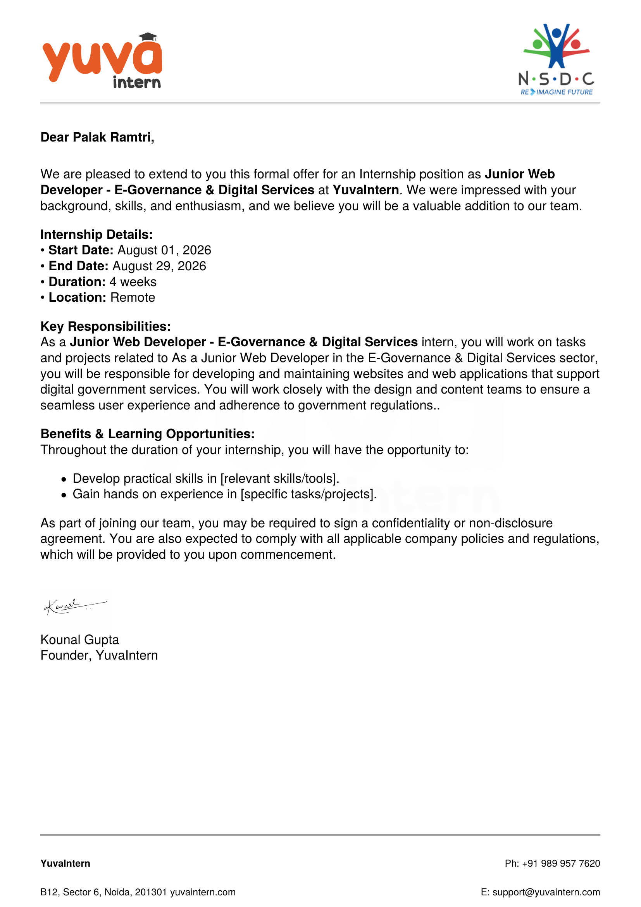

4. PROJECT DESCRIPTION
4.1 Introduction
This report presents a detailed account of the 4-week internship undertaken from 1st August 2026 to 29th August 2026 with YuvaIntern, in the role of Junior Web Developer – E-Governance & Digital Services. E-Governance refers to the use of information and communication technology (ICT) to deliver government services, exchange information, and integrate stand-alone systems between government and citizens, government and business, and inter-agency relationships. As part of this internship, the intern was assigned to plan, prototype, build, and audit a citizen-facing digital service – an Online Property Tax Payment Portal – that reflects real-world challenges faced by municipal e-governance platforms.
The internship followed a structured, week-wise curriculum that combined conceptual learning with hands-on assignments: Planning & Requirements Analysis, Responsive Web Prototype Design, Backend Integration & Database Management, and Performance, Accessibility & Security Audit, together simulating the complete lifecycle of a digital-service project from conception to audit-ready delivery. On successful completion of all requirements, a Certificate of Experience was awarded by YuvaIntern. This chapter documents the internship experience, the host organization, the problem addressed, the objectives, the scope, the technologies used, the system architecture, the methodology followed, and the outcomes achieved.
4.2 Organization Profile
YuvaIntern is a virtual internship and skill-certification platform that provides students with hands-on, project-based internship experience across domains such as web development, data science, digital marketing, and e-governance technologies. The platform issues a Certificate of Experience on successful completion of an internship and operates in partnership with the National Skill Development Corporation (NSDC), reflecting its alignment with national skill-development initiatives. YuvaIntern functions under the umbrella of the Henry Harvin group of companies, which maintains offices in the United States, India (Noida, Uttar Pradesh), and the United Arab Emirates. Through structured, mentor-guided weekly assignments, YuvaIntern enables student interns to build practical, portfolio-ready projects while receiving feedback on their technical and professional competencies.
4.3 Problem Statement
Municipal property tax collection in many Indian towns and cities continues to rely on manual, in-person, or paper-based processes for assessment, billing, and payment. This creates several persistent problems: long queues and waiting times at municipal offices, delays and errors in manual record-keeping, limited transparency for citizens regarding dues and payment history, restricted office-hour availability that excludes working citizens, and higher administrative overheads for local bodies. These inefficiencies are compounded for elderly, disabled, or remote citizens who find physical visits especially burdensome.
The problem addressed by this internship project was therefore to design and build a secure, accessible, and user-friendly Online Property Tax Payment Portal that allows citizens to view property tax assessments, calculate dues, make payments digitally, and retrieve receipts at any time – thereby reducing the administrative burden on municipal staff and improving service delivery in line with the Digital India programme's e-governance objectives.
4.4 Project Objectives
The specific objectives of the internship project were:
- To analyse citizen and administrator requirements for an online property tax payment service.
- To design a responsive, accessible web prototype for the portal covering desktop, tablet, and mobile users.
- To design and implement backend integration and database management for the portal, including system architecture, database schema design, secure API design, and backup & recovery planning.
- To conduct a performance, accessibility (WCAG), and security audit of the prototype and recommend improvements.
- To gain practical, hands-on experience with the end-to-end lifecycle of an e-governance digital-service project.
4.5 Scope of the Project
The scope of the project covered the planning, prototyping, backend/database design, and auditing of an Online Property Tax Payment Portal intended for use by individual property owners and municipal administrators.
In scope:
- Citizen registration and secure login.
- Property search and display of tax assessment details.
- Online property-tax calculation.
- Digital payment processing (UPI / card / net-banking simulation).
- Downloadable payment receipts and payment-history tracking.
- Backend system design and a normalized database schema for property, citizen, and transaction records.
- A basic administrator view for managing property and payment records.
Out of scope for this internship phase:
- Integration with a live government payment gateway.
- Integration with an actual municipal property database.
- Full production deployment, as these require institutional access beyond the scope of a student internship.
4.6 Technologies and Tools Used
The following technologies and tools were used across the different stages of the project:
Category | Tools / Technologies
Frontend | HTML5, CSS3, JavaScript, Bootstrap
Design & Prototyping | Figma (wireframes and mockups)
Backend & API Design | Node.js / Express.js, RESTful APIs
Database Design | MySQL, ER-diagram/schema design
Version Control | Git and GitHub
Testing | Manual test-case design, Postman (API testing), browser DevTools
Accessibility & Performance Audit | Google Lighthouse, WAVE Accessibility Checker
Security Reference | OWASP Top 10 guidelines
4.7 System Architecture
The Online Property Tax Payment Portal was designed around a standard three-tier web architecture:
- Presentation Layer: A responsive front end built with HTML5, CSS3, and JavaScript (Bootstrap-based), delivering the citizen-facing interface, including registration, tax lookup, payment, and receipt screens.
- Application / Logic Layer: A server-side layer responsible for authentication, tax-calculation logic, payment-flow orchestration, and RESTful API endpoints connecting the front end to the data layer.
- Data Layer: A relational database (MySQL) with a normalized schema storing property records, citizen accounts, tax assessments, and payment transaction history.
This layered structure separates concerns between interface, business logic, and data persistence; supports independent testing of each layer; and can be extended to integrate with external government payment gateways in a future production phase. As part of the backend and database design work, basic backup and recovery procedures were also planned to safeguard citizen and transaction data against loss or corruption.
Data flow: Citizen Browser → Presentation Layer → Application / Logic Layer → Data Layer (MySQL).
4.8 Methodology
The internship followed an iterative, document-driven methodology, with each week producing a distinct deliverable that built on the previous week's work. All code and design artifacts were version-controlled on GitHub.
Week | Focus Area | Key Deliverable
Week 1  (1 – 7 Aug 2026) | Planning & Requirements Analysis | Requirement report describing the proposed e-governance service and initial GitHub repository setup
Week 2  (8 – 14 Aug 2026) | Responsive Web Prototype Design | Wireframes/mockups and design-rationale report covering accessibility, responsiveness, and usability
Week 3  (15 – 21 Aug 2026) | Backend Integration & Database Management | System architecture design, database schema design, secure API design, and backup & recovery planning for the portal's data layer
Week 4  (22 – 29 Aug 2026) | Performance, Accessibility & Security Audit | Audit report with performance KPIs, WCAG accessibility assessment, security vulnerability analysis, and recommendations
Project code and artifacts are version-controlled at: github.com/PalakRamtri/Online-Property-Tax-Payment-Portal.
4.9 Expected Outcomes
- A working prototype/wireframe-level design of a citizen-facing Online Property Tax Payment Portal.
- A backend system design with a normalized database schema and secure API architecture for property, citizen, and transaction data.
- A performance and accessibility audit demonstrating alignment with WCAG guidelines and improved page-performance metrics.
- A security assessment referencing the OWASP Top 10 to reduce the platform's exposure to common web vulnerabilities.
- Practical, portfolio-ready experience in end-to-end e-governance digital-service design, aligned with the Digital India programme's push toward citizen-centric online services.
4.10 Certificates of Completion and Communication Proof
The Internship Offer Letter and the Internship Completion Certificate issued by YuvaIntern (Certificate No. YI/2026/183585/406976, dated August 29, 2026), confirming successful completion of the 4-week internship as Junior Web Developer – E-Governance & Digital Services, are attached in Chapter 3 of this report and reproduced below for ready reference.

Application Confirmation Email

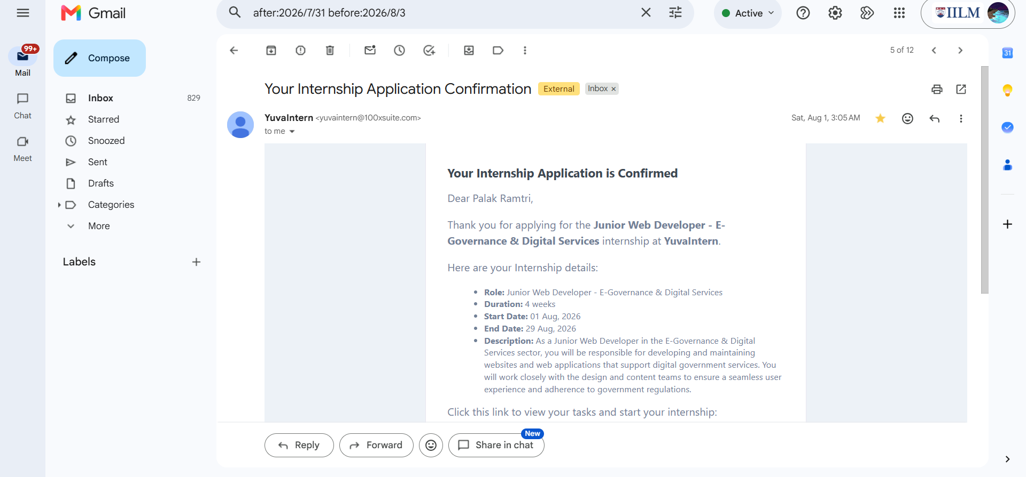
Certificate Request Email

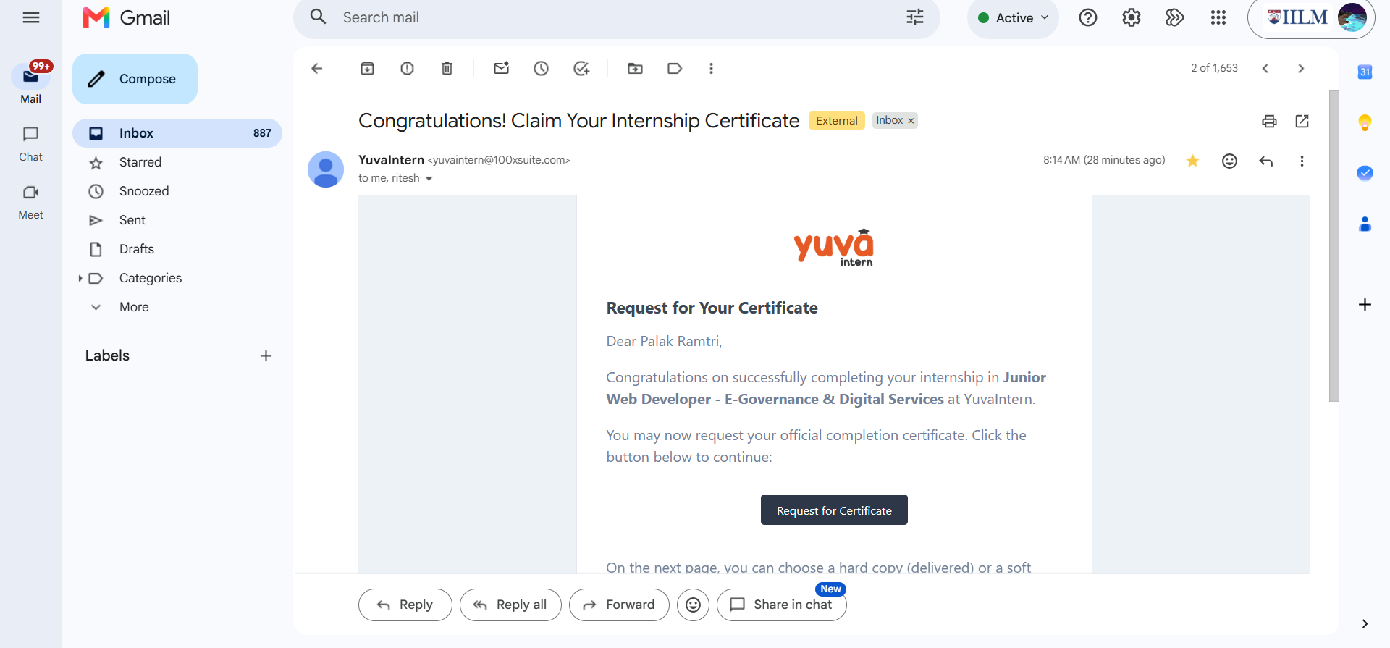

5. BIBLIOGRAPHY/REFERENCES
1. YuvaIntern, “Internship Offer Letter – Junior Web Developer, E-Governance & Digital Services,” 2026.
2. YuvaIntern, “Certificate of Experience – Palak Ramtri,” Certificate No. YI/2026/183585/406976, Issued August 29, 2026.
3. World Wide Web Consortium (W3C), Web Content Accessibility Guidelines (WCAG) 2.1, https://www.w3.org/WAI/standards-guidelines/wcag/
4. OWASP Foundation, OWASP Top 10 Web Application Security Risks, https://owasp.org/www-project-top-ten/
5. Google Developers, Lighthouse Performance and Accessibility Auditing Tool, https://developer.chrome.com/docs/lighthouse/
6. Ministry of Electronics and Information Technology, Government of India, Digital India Programme, https://www.digitalindia.gov.in/
7. GitHub Repository: Online Property Tax Payment Portal, https://github.com/PalakRamtri/Online-Property-Tax-Payment-Portal

